|  |  |  |
| --- | --- | --- |
| **Item** | **Grade** | **Comment** |
| Use case diagram: 2 points |  |  |
| Main flow: 4 points |  |  |
| Exceptional (Alternative) flow: 2 points each |  |  |
| Non-functional requirements: 3 points |  |  |
| **Total: 15 points** |  |  |

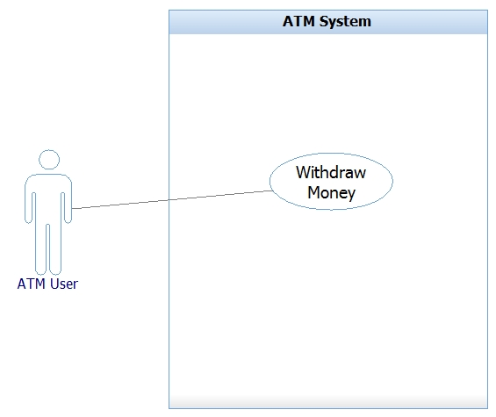

|  |
| --- |
| **USE CASE NAME: Withdraw Money** |
| **ACTOR(s): ATM User** |
| **GOAL:** The ATM User will withdraw money from his/her bank account |
| **PRECONDITION:**   1. ATM User has a bank card to use the ATM System 2. ATM System is running |
| **MAIN SUCCESS SCENARIO:**   1. ATM User swipes bank card 2. ATM System asks for PIN number 3. ATM User enters PIN number 4. ATM System displays transaction options 5. ATM User activates withdraw money function 6. ATM System displays withdrawing options 7. ATM User activates the function that correlates with the amount of money wanted 8. ATM System dispenses money 9. ATM User accepts money 10. ATM System displays options to end session or to perform another transaction 11. ATM User activates end session function 12. ATM System closes ATM user’s account   **POSTCONDITION:**   1. ATM User has cash that was withdrawn from the ATM 2. ATM System is ready to accept another bank card |
| **EXCEPTIONS:**   1. ATM User enters wrong PIN number 2. ATM User requests more money than what is available in the account 3. ATM System cannot dispense the amount of money requested |
| **TRACING TO NON-FUNCTIONAL REQUIREMENTS:**   1. The requested amount of money will be dispensed within 5 seconds of approved request. 2. The account information will be retrieved within 3 seconds of swiping the bank card. 3. The ATM System will be ready to accept another bank card within 6 seconds of ending the last transaction. 4. The ATM System’s interface will include simple text boxes |

|  |
| --- |
| **USE CASE NAME: Exception 1** |
| **ACTOR(s): ATM User** |
| **GOAL:** The ATM User enters an incorrect PIN number |
| **PRECONDITION:**   1. ATM User swipes the ATM card 2. ATM System requests PIN number |
| **MAIN SUCCESS SCENARIO:**   1. ATM User enters PIN number 2. ATM System displays invalid PIN number message 3. ATM System requests the PIN number again 4. ATM User enters PIN number   **POSTCONDITION:**   1. ATM System accepts PIN number |

|  |
| --- |
| **USE CASE NAME: Exception 2** |
| **ACTOR(s): ATM User** |
| **GOAL:** The ATM User attempts to withdraw more money than what is available |
| **PRECONDITION:**   1. ATM User activates withdraw money function 2. ATM System displays amount options |
| **MAIN SUCCESS SCENARIO:**   1. ATM User activates the function that correlates with the amount of money wanted 2. ATM System displays insufficient funds message 3. ATM System displays amount options 4. ATM User activates the function that correlates with the amount of money wanted   **POSTCONDITION:**   1. ATM System dispenses requested amount of money |

|  |
| --- |
| **USE CASE NAME: Exception 3** |
| **ACTOR(s): ATM User** |
| **GOAL:** The ATM System cannot dispense the requested amount of money |
| **PRECONDITION:**   1. ATM User activated the function that correlates with the amount of money wanted |
| **MAIN SUCCESS SCENARIO:**   1. ATM System displays error message 2. ATM System displays options for another transaction or end of session 3. ATM User activates another transaction function   **POSTCONDITION:**   1. ATM System displays transaction options |
|  |